- Introduction to Networking & the OSI Model Theory

Q1. Install Wireshark on your laptop, start a capture on your main network interface, and visit any website (like instagram.com). Stop the capture and note down the protocol names you see in the packet list?

Answer

- Wireshark Packet Capture
I started a packet capture on my main Wi-Fi interface in Wireshark and browsed a website. After stopping the capture, I checked the Protocol column.
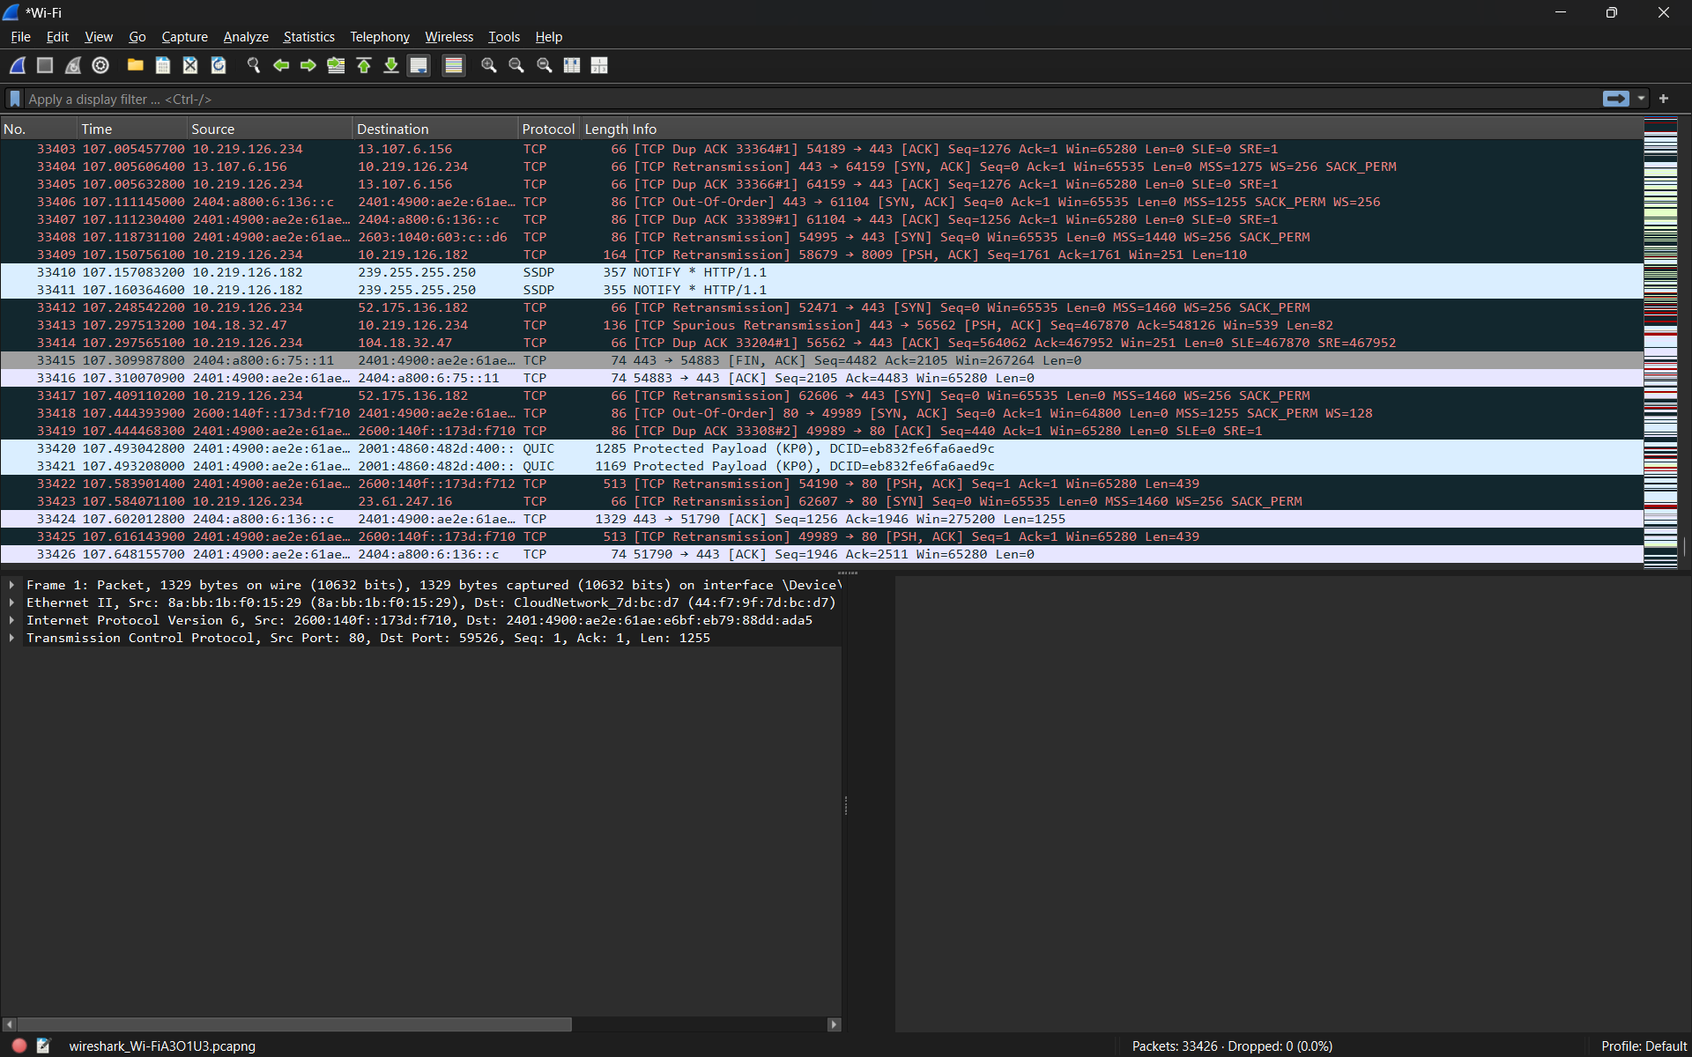
Protocols observed: TCP, SSDP, and QUIC.
- Result:
Wireshark successfully captured network traffic from my Wi-Fi connection and displayed different protocols used during internet communication.

Q2. Pick any 3 packets from your Wireshark capture and identify which OSI layer each packet mainly represents (for example, HTTP for Application layer, TCP for Transport layer, etc.).<br><br><em><strong>Hint:</strong> Use the Protocol column and Info details in Wireshark to help you map protocols to OSI layers.</em>?

Answer
- Identifying OSI Layers from Wireshark Packets
From my Wireshark capture, I selected three protocols and identified the OSI layer they mainly represent.
Protocol | OSI Layer | Explanation
- TCP | Layer 4 – Transport | TCP provides reliable delivery of data between devices.
- SSDP | Layer 7 – Application | SSDP helps devices discover services on a network.
- IPv6 | Layer 3 – Network | IPv6 provides logical addressing and helps route packets between networks.

- Result:
The Wireshark capture showed protocols working at different OSI layers, including SSDP at the Application layer, TCP at the Transport layer, and IPv6 at the Network layer.

Q3. Create a colorful diagram of the OSI Model using any drawing tool (MS Paint, Canva, or even paper and upload a photo). For each layer, add a real-world example from apps you use daily (e.g., WhatsApp uses the Application layer, Instagram images use the Presentation layer, etc.)?

Answer

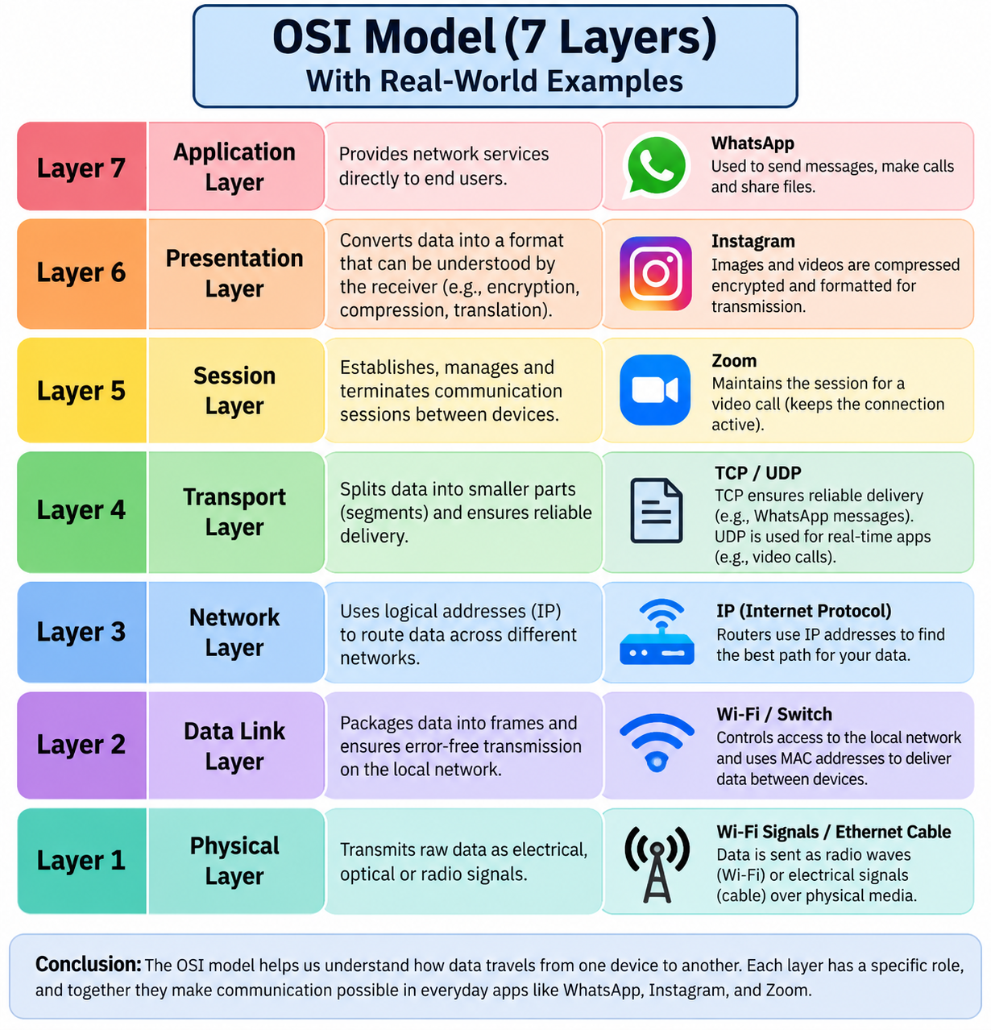
- Explanation:
The diagram shows all seven layers of the OSI Model with real-world examples. Each layer performs a different function, from applications such as WhatsApp at the Application layer to Wi-Fi signals and Ethernet cables at the Physical layer. Together, these layers help data move correctly from one device to another.
Q4. Explain how sending a message on WhatsApp travels through at least 4 layers of the OSI Model, describing what happens at each layer in your own words.<br><br><em><strong>Hint:</strong> Think about how your message is typed, packaged, sent over the internet, and received.</em>?

Answer

- How a WhatsApp Message Travels Through the OSI Model
When I send a message on WhatsApp, different OSI layers help move the data from my phone to the receiver.
- Application Layer (Layer 7):
I type the message in WhatsApp and press Send. WhatsApp prepares the message data for transmission.
- Transport Layer (Layer 4):
The data is divided into smaller parts and transported across the network using transport protocols.
- Network Layer (Layer 3):
IP addresses are used to route the data through different networks so that it reaches the correct destination.
- Data Link Layer (Layer 2):
The data is placed into frames and sent through the local Wi-Fi or mobile network.
- Physical Layer (Layer 1):
The data is finally transmitted as radio signals or electrical signals.
- Result:
At the receiver’s side, the data passes through the OSI layers in reverse order, and the WhatsApp message appears on the screen.

